Read me

Team member:

Liang Xubin (3035420053)

Tu Chao (3035419250)

Zhou Guancong (3035420211)

(Order by surname)

**Compile SDK Version:** API 26: Android 8.0 (Oreo)

**API Level:** 24

**AVD setting:** 4.0, 480*800, hdpi (Nexus S)

**Android studio version:** 3.0

And you have to give this APP some permission:

1. Click the <Call Steward>APP, and turn <No> to <Yes>.

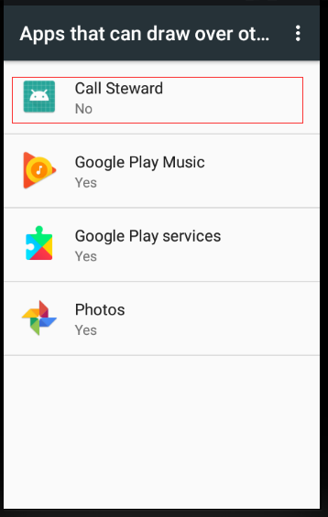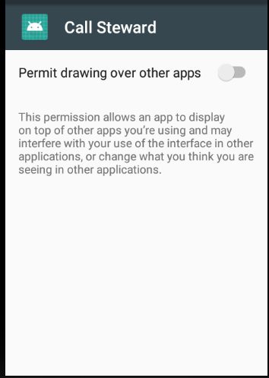

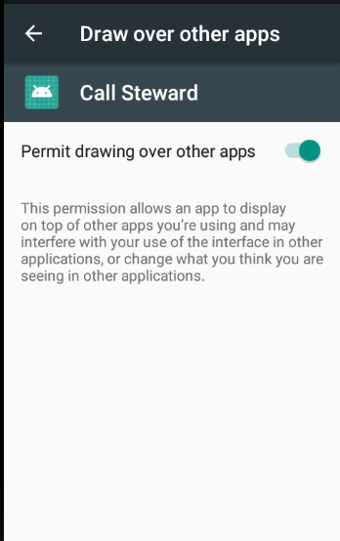

Then click the button<return>

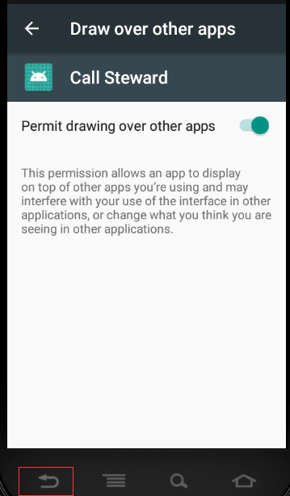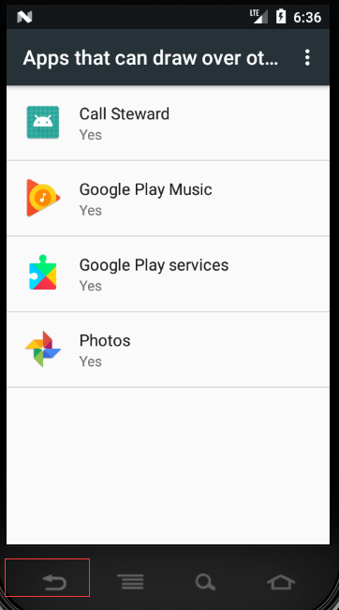

1. Click <ALLOW>

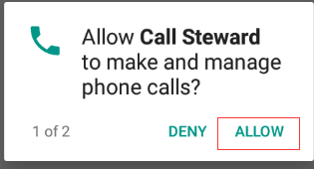

1. Click <ALLOW>

